AML TRANSACTION & FRAUD ANALYSIS DASHBOARD
USING MICROSOFT POWER BI
PROJECT REPORT
Submitted By
Name: Shibani Sri. U
Register Number: E25FA042
Course: B. Com Fintech & AI
Tool Used: Microsoft Power BI Desktop

INTRODUCTION:
For this project, I developed an interactive AML Transaction & Fraud Analysis Dashboard using Microsoft Power BI Desktop. The purpose of this project is to examine financial transaction data and understand how data analysis can support the identification and monitoring of suspicious financial activities.
AML stands for Anti-Money Laundering. It refers to the measures taken to identify and prevent illegal financial activities, including money laundering and suspicious transactions. Financial institutions process a large number of transactions every day. Therefore, manually examining every transaction can be challenging. Data analysis and visualisation tools help organise this information and make unusual transaction patterns easier to identify.
The dataset used in this project contains details about financial transactions, transaction amounts, timestamps, account information, fraud classifications and alert categories. These details help analyse transaction activities and understand how transactions are classified as fraudulent or non-fraudulent.
To develop the dashboard, I first imported the dataset into Power BI and examined its available fields. After preparing the data, I created different KPI cards, charts and interactive slicers to present the information in an understandable format.
The dashboard displays important details such as total transaction amount, total transactions, total accounts and fraudulent transactions. It also includes visualisations for transaction volume over time, fraudulent transaction volume, transaction value by fraud status and alert counts based on alert types such as Cycle and Fan_in.
Additionally, I included slicers for fraud status and alert type, allowing users to filter the information and examine particular transaction categories.
Through this project, I aimed to gain practical knowledge of Power BI and understand how financial data can be converted into useful visual information for analysing transaction patterns and possible fraudulent activities.
OBJECTIVES:
The major objectives of developing this dashboard are:
- To understand the meaning and importance of Anti-Money Laundering and fraud analysis.
- To examine financial transaction activities using the available dataset.
- To calculate and display important financial indicators, including total transaction amount, total transactions, total accounts and fraudulent transactions.
- To study changes in transaction volume across different timestamps.
- To examine the movement of fraudulent transactions over time.
- To compare transaction amounts between fraudulent and non-fraudulent categories.
- To understand how transactions are distributed according to their fraud status.
- To examine the different alert categories, including Cycle and Fan_in.
- To identify transaction patterns that may need additional attention.
- To develop interactive slicers for filtering and exploring the available information.
- To improve practical skills in Microsoft Power BI, DAX and data visualisation.
- To understand how dashboards can present large datasets in a clear and meaningful manner.
DATASET DESCRIPTION:
For this project, I selected an AML Transaction and Fraud Analysis dataset that contains information about financial transactions and related fraud activities. The dataset includes several fields that are useful for examining transaction values, account details, fraud classifications and alert information.
The important fields used in the dashboard are explained below:
Field Name | Description
TIMESTAMP | Shows the time or sequence connected with a financial transaction.
TRANSACTION AMOUNT | Represents the amount of money involved in a transaction.
TRANSACTION ID | Provides a unique identification number for each transaction.
ACCOUNT ID | Identifies the account associated with a transaction.
IS_FRAUD | Indicates whether a transaction is classified as fraudulent or non-fraudulent.
ALERT_ID | Represents the unique identification number assigned to a fraud alert.
ALERT_TYPE | Specifies the category of alert associated with a particular transaction pattern.

Types of Alerts:
The dashboard displays two main alert categories:
1. Cycle
Cycle refers to a transaction pattern where money moves between different accounts in a circular sequence. The movement may eventually return to the original account or another connected account.
For example, money may move from Account A to Account B, then to Account C, and finally return to Account A. Such transaction patterns can be examined to understand the movement of funds and identify activities that may require further investigation.
2. Fan_in
Fan_in describes a transaction pattern in which funds are received from several different accounts into one particular account.
For example, multiple accounts may transfer money into a single account. Analysing this pattern helps examine where the funds originate and whether the transactions require additional attention.
These fields provide the basic information needed to study transaction activities, fraud classifications and different alert patterns.
DATA PREPARATION USING POWER QUERY:
Before developing the dashboard, I prepared the dataset using Microsoft Power BI Desktop. Data preparation is an important process because properly organised data helps produce meaningful and reliable visualisations.
The following activities were carried out during the preparation stage:
- Importing the Dataset: First, I opened Power BI Desktop and imported the AML Transaction and Fraud Analysis dataset.
- Checking Available Columns: After importing the file, I examined the column names and their contents to understand the information available.
- Verifying Data Types: I checked the data types of different columns to ensure that numerical and text fields were recognised correctly.
- Transaction Amount: I examined the Transaction Amount column to ensure that it could be used for calculating the total transaction value.
- Timestamp Field: I checked the Timestamp column because it is required to examine transaction activities over time.
- Account Information: I reviewed the Account ID field to understand the accounts represented in the dataset.
- Fraud Classification: I examined the IS_FRAUD field, which contains True and False values to distinguish fraudulent and non-fraudulent transactions.
- Alert Information: I checked the ALERT_ID and ALERT_TYPE fields to understand the available alert categories.
After reviewing the required fields and preparing the data for analysis, I proceeded to create the DAX measures and develop the dashboard visualisations.
DAX MEASURES USED:
DAX stands for Data Analysis Expressions. It is a formula language available in Power BI that is used to perform calculations and create measures from the dataset. In this project, I used different measures to calculate important transaction details and display them through KPI cards and charts.
The major measures used in the dashboard are explained below:
- Total Transaction Amount
This measure calculates the combined monetary value of all the transactions recorded in the dataset.
Purpose:
It helps identify the overall financial value of the transactions. It provides a summary of the total amount involved in the recorded financial activities.
- Total Transactions
This measure calculates the total number of transaction records available in the dataset.
Purpose:
It provides information about the overall volume of transactions and helps understand the number of financial activities recorded.
- Total Accounts
This measure calculates the number of accounts represented in the dataset.
Purpose:
It helps understand how many accounts are involved in the recorded transaction activities and gives an overview of the account network.
- Fraudulent Transactions
This measure identifies and counts the transactions classified as fraudulent using the IS_FRAUD field.
Purpose:
It helps determine the number of transactions marked as fraudulent and provides an overview of the records that may require further examination.
- Transaction Volume Across Timestamp
This calculation is used to examine the number of transactions recorded at different timestamps.
Purpose:
It helps understand how transaction activities vary over time. A line chart is used to display these changes and identify periods with higher or lower transaction volumes.
- Fraudulent Transaction Volume
This calculation focuses on the number of transactions classified as fraudulent across different timestamps.
Purpose:
It helps examine how fraudulent transaction activities change over time and makes it easier to identify periods that may need additional attention.
These DAX measures help convert the available transaction information into useful numerical results and improve the overall understanding of the dashboard.
DASHBOARD VISUALISATIONS:
The dashboard was developed using different visualisation features available in Microsoft Power BI. Each chart represents a particular aspect of the financial transaction and fraud information.
The following visualisations are included in the dashboard:
1. KPI CARDS
Four KPI cards are placed at the top of the dashboard to highlight the most important information.
The cards display the following values:

KPI | Value
Total Transaction Amount | 153.48bn
Total Transactions | 1M
Total Accounts | 10K
Fraudulent Transactions | 2K

These cards provide a quick summary of the dataset and allow users to understand the main transaction indicators without examining every chart. The Total Transaction Amount represents the overall monetary value of the recorded transactions. Total Transactions shows the number of transactions available in the dataset. Total Accounts indicates the number of accounts represented, while Fraudulent Transactions displays the number of transactions classified as fraudulent cards make the important figures easily visible and improve the readability of the dashboard.

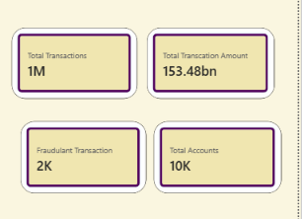
2. TRANSACTION VOLUME ACROSS TIMESTAMP
A line chart is used to represent the number of transactions recorded across different timestamps. The horizontal axis displays the timestamp, while the vertical axis represents the transaction count. This chart shows how transaction activities change over the recorded period. It helps identify variations in transaction volume, including periods with higher and lower activity. By examining this visualisation, users can understand the general movement of transaction activities and observe changes across different time periods. This chart is useful for monitoring transaction patterns and identifying unusual changes that may require further examination.

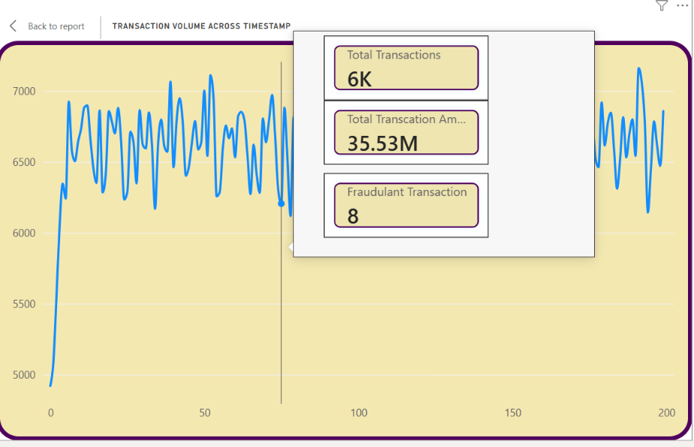

3. FRAUDULENT TRANSACTION VOLUME ACROSS TIMESTAMP
A separate line chart is used to examine the number of fraudulent transactions across different timestamps. The previous line chart represents all transaction activities, whereas this visual focuses specifically on transactions classified as fraudulent. It displays how the volume of fraudulent transactions changes over time. This makes it possible to observe whether fraud-related activities increase, decrease or remain relatively consistent during different periods. For example, an increase in fraudulent transaction volume during a particular period may indicate a pattern that needs further investigation. This visualisation helps examine fraud-related activities separately from the overall transaction volume.

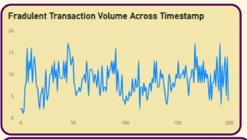

4. TOTAL TRANSACTION VALUE BY FRAUD STATUS
A column chart is used to compare the total transaction amount according to fraud classification.
The chart displays two categories:
- False: Represents transactions classified as non-fraudulent.
- True: Represents transactions classified as fraudulent.
The horizontal axis represents the fraud status, while the vertical axis displays the total transaction value. From the dashboard, it can be observed that the transaction value under the False category is considerably higher than the value under the True category. This chart helps users understand how the total financial value is divided between fraudulent and non-fraudulent transactions. It also makes the comparison between the two classifications easier to understand.

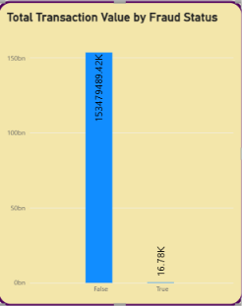
5. COUNT OF ALERT_ID BY ALERT_TYPE
A horizontal bar chart is used to compare the number of alerts recorded under different alert categories.
The chart includes two categories:
- Cycle
- Fan_in
The horizontal axis displays the count of ALERT_ID, while the vertical axis represents the alert categories. The dashboard shows that Cycle has a higher alert count than Fan_in. This visualisation helps compare the frequency of different alert types and understand how they are distributed in the dataset. Cycle represents circular movement of funds between accounts, whereas Fan_in represents funds received from multiple accounts into a single account.
A horizontal bar chart makes it easier to compare the two categories and understand their recorded alert counts.
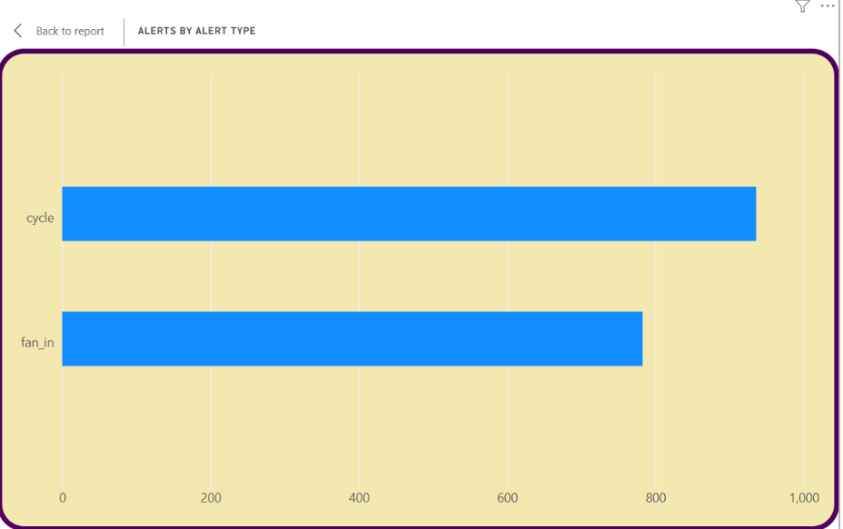
6. TRANSACTION DISTRIBUTION BY FRAUD STATUS
A doughnut chart is used to show how transactions are distributed according to their fraud classification.
The chart contains two categories:
- False: Non-fraudulent transactions.
- True: Fraudulent transactions.
The doughnut chart displays the proportion of transactions belonging to each category. From the dashboard, it can be observed that non-fraudulent transactions represent the larger share of the total transaction volume, while fraudulent transactions account for a comparatively smaller share. This visual provides a simple way to understand the distribution of transactions without examining individual records.
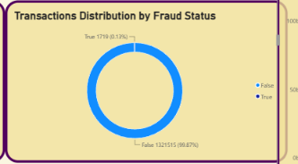

FILTERS AND SLICERS:
Slicers are interactive features in Power BI that allow users to filter the information displayed in a dashboard.
In this project, I included two slicers to make the analysis more flexible.
1. IS_FRAUD SLICER
The IS_FRAUD slicer contains two selection options:
- False
- True
This slicer allows users to filter the dashboard according to the fraud classification. Selecting True helps focus on transactions classified as fraudulent, while selecting False displays information related to non-fraudulent transactions. It makes it easier to examine the two categories separately and compare their related information.

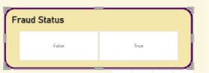
2. ALERT_TYPE SLICER
The ALERT_TYPE slicer includes two available options:
- Cycle
- Fan_in
This slicer allows users to select a particular alert category and examine the corresponding information. Selecting Cycle helps focus on cycle-related alerts, whereas selecting Fan_in allows users to analyse the alerts associated with funds received from multiple accounts.
These slicers make the dashboard more flexible and allow users to explore the information based on their selected requirements.

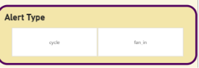
DASHBOARD INTERACTIVITY:
Interactivity is an important feature of Microsoft Power BI because it allows users to explore information through different selections and filters.
In this project, I used the IS_FRAUD and ALERT_TYPE slicers to make the dashboard interactive.
The following features are available:
- Selecting True in the IS_FRAUD slicer allows users to focus on fraudulent transactions.
- Selecting False helps users examine non-fraudulent transactions.
- Choosing Cycle in the ALERT_TYPE slicer displays the information related to that alert category.
- Selecting Fan_in helps examine the corresponding alert information.
- Users can change their selections to compare different transaction classifications and alert categories.
When a user selects a slicer option, the connected visualisations respond according to the filter and interaction settings configured in Power BI. These features allow users to examine the dataset from different perspectives without creating separate reports for each category. Overall, dashboard interactivity makes the analysis more convenient and helps users explore the available information effectively.
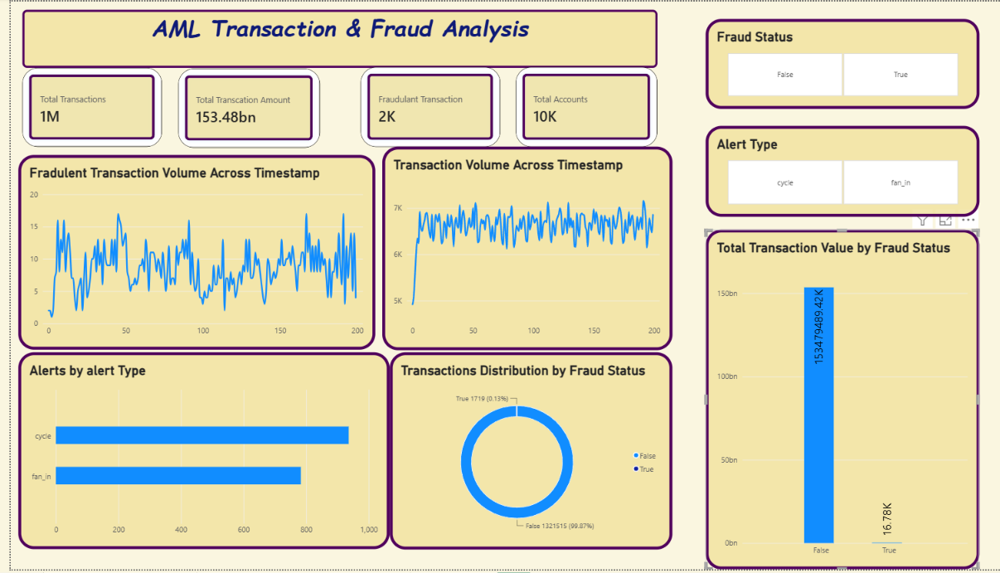
KEY FINDINGS:
After developing and examining the dashboard, I identified the following observations:
- The total transaction amount displayed in the dashboard is approximately $153.48 billion.
- The dataset contains approximately 1 million transactions.
- The total number of accounts represented is approximately 10,000.
- Approximately 2,000 transactions are classified as fraudulent.
- The transaction volume line chart displays changes in transaction activities across different timestamps.
- The fraudulent transaction volume chart helps examine variations in fraud-related activities over time.
- The transaction value comparison shows a considerable difference between the False and True fraud classifications.
- Non-fraudulent transactions account for the larger portion of the overall transaction distribution.
- Fraudulent transactions represent a comparatively smaller share of the total transaction volume.
- The dashboard includes two alert categories: Cycle and Fan_in.
- Cycle alerts have a higher recorded count than Fan_in alerts in the displayed chart.
- The horizontal bar chart provides an easy comparison of the two alert categories.
- The IS_FRAUD slicer allows users to examine fraudulent and non-fraudulent transactions separately.
- The ALERT_TYPE slicer helps users explore specific alert categories.
- The combination of KPI cards, line charts, a column chart, a horizontal bar chart and a doughnut chart provides different views of the transaction information.
These findings helped me understand how financial transaction data can be examined using different visualisation techniques and how certain patterns can be identified for further investigation.
CONCLUSION:
The AML Transaction & Fraud Analysis Dashboard project helped me understand how Microsoft Power BI can be used to examine financial transactions and present fraud-related information in an interactive format.
Using the AML Transaction and Fraud Analysis dataset, I developed a dashboard containing KPI cards, transaction volume trends, fraudulent transaction analysis, transaction value comparisons, alert category analysis and fraud status distribution.
The KPI cards provide an overview of the total transaction amount, total transactions, total accounts and fraudulent transactions. The line charts help examine transaction activities across different timestamps, while the column chart and doughnut chart explain how transaction information is distributed according to fraud status.
The horizontal bar chart provides a comparison of alert categories such as Cycle and Fan_in. In addition, the slicers allow users to filter the dashboard based on fraud status and alert type, making the analysis more convenient.
Through this project, I gained a basic understanding of Anti-Money Laundering and the importance of examining financial transactions for unusual patterns. I also improved my practical knowledge of data preparation, DAX measures, data visualisation and interactive dashboard creation.
Overall, this project provided an opportunity to apply Power BI concepts practically and understand how visual dashboards can make large amounts of financial information easier to organise, examine and interpret.

